TEA BLISS

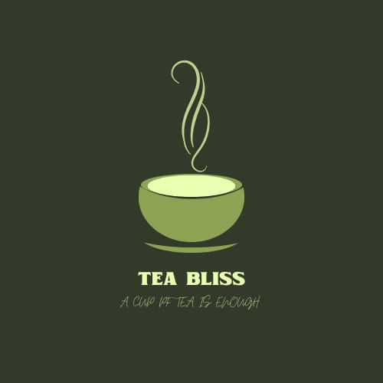

1.INTRODUCTION

1.1 Overview

1.2 Purpose

2. PROBLEM DEINITION & DESIGN THINKING

2.1 Empathy map

2.3 Ideation & brainstorming map

3.RESULT

4.ADVANTAGES & DIADVANTAGES

5.APPLICAION

6.CONCLUSION

1.INTRODUCTION

1.1 Overview

Chai is an excuse to share great thoughts 100% Natural Indian Spices and Herbs Founded in 2023 ,tea bliss is among the world's vertically integrated online -offline tea brand's.we sources premium garden Fresh teas direct from an indian tea plantations & delivers to consumers across the world..

1.2 Purpose

Tea serves various purposes and can be enjoyed for a multitude of reasons, both functional and cultural. Here are some common purposes of tea:

1. Refreshment: Many people enjoy tea simply for its refreshing and hydrating qualities. It can be a comforting and soothing beverage.
2. Caffeine Boost: Tea contains caffeine, which provides a mild energy boost. Some people drink tea to help increase alertness and combat fatigue.
3. Relaxation: Certain types of tea, such as herbal teas like chamomile or lavender, are known for their relaxing properties. They can help reduce stress and promote better sleep.
4. Medicinal Benefits: Tea has been used for its potential health benefits for centuries. Various herbal teas are believed to have healing properties and can be used to alleviate symptoms of various ailments, like ginger tea for nausea or peppermint tea for digestive issues.
5. Social and Cultural Traditions: Tea is an integral part of many cultures and social rituals. In some societies, tea ceremonies are deeply rooted in tradition and hold special significance.
6. Taste and Enjoyment: Tea comes in a wide variety of flavors and blends, from black and green teas to fruit-infused and spiced teas. Many people drink tea simply because they enjoy the taste and aroma.
7. Antioxidants: Some types of tea, such as green tea, are rich in antioxidants, which can have potential health benefits, including reducing the risk of certain diseases.
8. Weight Management: Some teas are marketed as aids for weight management, although their effectiveness is often debated. Green tea, for example, is sometimes associated with metabolism-boosting properties.
9. Hydration: Tea is mostly water, so it contributes to daily hydration needs.
10. Cultural Traditions: Tea plays a significant role in the cultural practices and rituals of many countries. For example, in Japan, the tea ceremony is a highly structured and revered cultural event.

Ultimately, the purpose of tea varies from person to person. Some may drink it for its health benefits, while others appreciate it for its flavor or as part of their daily routine. Tea can be versatile and serve different purposes in different contexts

2. PROBLEM DEINITION & DESIGN THINKING

2.1 Empathy map

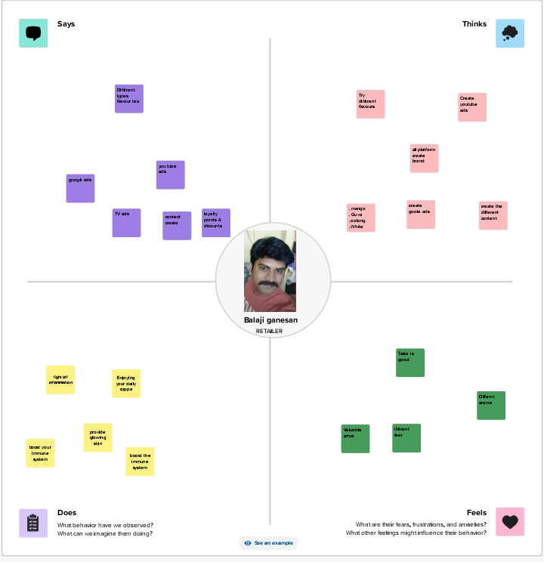



2.3 Ideation & brainstorming map

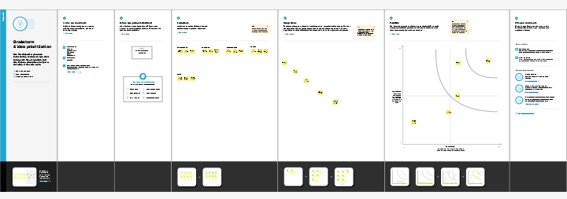



3.RESULT

The success of tea marketing campaigns can yield various results, depending on the goals and strategies employed. Here are some possible outcomes of effective tea marketing efforts:

1. Increased Sales: A primary goal of tea marketing is to boost sales. Successful marketing campaigns can lead to increased demand for tea products, resulting in higher sales and revenue for tea companies.
2. Brand Awareness: Effective marketing can enhance brand recognition and awareness. Consumers are more likely to choose familiar and reputable tea brands, which can lead to long-term customer loyalty.
3. Market Expansion: Tea marketing can help companies enter new markets or expand their presence in existing ones. This can be achieved through targeted advertising and market research.
4. Product Innovation: Marketing efforts can drive innovation in the tea industry, leading to the development of new and unique tea products to meet changing consumer preferences.
5. Customer Engagement: Engaging marketing campaigns can foster a strong connection between tea companies and their customers. This can lead to repeat business and positive word-of-mouth referrals.
6. Improved Reputation: Effective marketing can help improve a company's reputation, emphasizing qualities such as quality, sustainability, and ethical sourcing.
7. Enhanced Online Presence: A successful digital marketing strategy can boost a tea brand's online presence, leading to increased website traffic, social media followers, and online sales.
8. Educational Content: Informative marketing materials can educate consumers about the benefits and uses of different types of tea, encouraging them to explore a wider variety of tea products.
9. Increased Market Share: Effective marketing can help tea brands capture a larger share of the market, which can be especially important in competitive industries.
10. Influencer Partnerships: Collaborations with tea influencers and celebrities can extend a brand's reach and credibility, leading to increased sales and exposure.
11. Sustainable Practices: Promoting sustainable and environmentally friendly tea production methods can resonate with consumers concerned about ethical and ecological issues.
12. Health and Wellness Trends: Aligning marketing efforts with health and wellness trends can attract health-conscious consumers looking for teas with specific health benefits.
13. Export Opportunities: Effective marketing can open up international markets and export opportunities for tea companies.
14. Community Engagement: Tea marketing campaigns that support and engage with local communities can build a loyal customer base and enhance the company's image.

The specific results of a tea marketing campaign depend on factors such as the target audience, the marketing channels used, the quality of the product, and the overall marketing strategy. A successful campaign can combine multiple factors to achieve a range of positive outcomes for tea companies.

4.ADVANTAGES & DIADVANTAGES

**Advantages**

1. **Market Growth:** The global tea market continues to grow, presenting opportunities for tea companies to increase sales and market share.
2. **Diverse Consumer Base:** Tea appeals to a wide and diverse consumer base, allowing for various marketing approaches to reach different demographics.
3. **Health Benefits:** Marketing tea as a healthy beverage can attract health-conscious consumers who are looking for natural and functional benefits.
4. **Cultural Appeal:** Tea is deeply rooted in the cultures of many countries, and marketing campaigns can tap into cultural traditions and rituals, which can be emotionally resonant.
5. **Customization:** Tea can be customized with different flavors, blends, and packaging, making it versatile for marketing to different consumer preferences.
6. **Sustainability Focus:** Highlighting ethical sourcing and sustainability practices can appeal to environmentally conscious consumers.
7. **Social Media Opportunities:** Tea companies can use social media to engage with consumers, showcase their products, and build a loyal online following.
8. **Innovation:** Tea marketing can promote new and unique tea products, such as specialty blends or innovative packaging, keeping the brand fresh and exciting.

**Disadvantages**

1. **Competition:** The tea market is highly competitive, with many brands and products, making it challenging to stand out.
2. **Price Sensitivity:** Consumers may be price-sensitive, especially when there are cheaper alternatives, which can limit pricing flexibility.
3. **Changing Consumer Preferences:** Consumer preferences for tea can change over time, requiring tea companies to adapt their marketing strategies and product offerings.
4. **Health Claims:** Marketing teas with health benefits may be subject to regulations and scrutiny, and claims must be accurate and substantiated.
5. **Cultural Sensitivity:** When marketing traditional teas, companies must be culturally sensitive and respectful to avoid backlash or misunderstandings.
6. **Supply Chain Challenges:** Sourcing high-quality tea leaves consistently and maintaining a stable supply chain can be challenging.
7. **Environmental Factors:** Climate change and environmental challenges can impact tea production, which may affect marketing strategies.
8. **Regulatory Compliance:** Tea marketing must comply with various regulations, such as labeling requirements and health claims, which can be complex and costly.
9. **Consumer Skepticism:** Consumers may be skeptical of marketing claims, especially if there is a perception of greenwashing or misleading advertising.
10. **Ethical and Social Responsibility:** The tea industry can face scrutiny related to labor practices and social responsibility, which can affect brand image and require additional efforts in marketing

5.APPLICAION

1. **Beverage:** The most common application of tea is as a beverage. People around the world enjoy tea for its diverse flavors and potential health benefits. Popular types include black tea, green tea, herbal tea, and white tea.
2. **Culinary:** Tea can be used in cooking and baking to infuse flavors into dishes. For example, tea leaves or tea bags can be used to flavor sauces, soups, and desserts. Earl Grey tea is often used to add a unique flavor to baked goods.
3. **Iced Tea:** Iced tea is a refreshing beverage made by brewing tea, sweetening it, and cooling it with ice. It's a popular summer drink and comes in various flavors.
4. **Flavor Enhancer:** Tea can be used to enhance the flavor of other beverages or cocktails. For example, adding tea to cocktails or mocktails can introduce unique and complex flavors.
5. **Health and Wellness:** Many people consume tea for its potential health benefits. Herbal teas like chamomile, ginger, and peppermint are known for their medicinal properties and are often used to alleviate various health issues.
6. **Cultural and Ceremonial:** Tea has significant cultural importance in various countries, leading to elaborate tea ceremonies, such as the Japanese tea ceremony and the Chinese gongfu cha. These ceremonies involve precise rituals and etiquette.
7. **Beauty and Skincare:** Tea extracts and tea-infused products are used in the beauty and skincare industry due to their antioxidant properties. Tea can be found in various skincare products like creams, masks, and serums.
8. **Aromatherapy:** The aroma of certain teas, especially herbal and floral varieties, is used in aromatherapy for relaxation and stress relief. Tea-scented candles and essential oils are also popular.
9. **Natural Dye:** Certain types of tea, like black tea, can be used as a natural dye for fabrics and paper, giving them a vintage or antique appearance.
10. **Stain Remover:** Tea can be used to remove stains from clothing and fabrics. It is particularly effective on certain types of stains, such as ink or lipstick.
11. **Fertilizer:** Used tea leaves can be added to compost or garden soil to enrich it with nutrients.
12. **Repellent:** Some people use brewed tea or tea bags as a natural insect repellent. The tannins in tea may help keep pests away.
13. **Jewelry Cleaning:** Tea can be used to clean and shine jewelry. The tannins can help remove tarnish and bring back the luster of metals.
14. **Household Cleaning:** Tea can be used as a cleaning agent for various surfaces. It can help remove stains and odors from carpets and upholstery

6.CONCLUSION

In conclusion, tea is a versatile and beloved beverage with a rich history, diverse flavors, and a wide range of applications. It has been an integral part of cultures and traditions worldwide and continues to evolve to meet the changing preferences and demands of consumers.

From its origins in ancient China to its global popularity today, tea serves multiple purposes. It is not only a beverage enjoyed for its taste and potential health benefits, but it also plays a significant role in cultural ceremonies and rituals. The tea industry has embraced innovation, offering various flavors, blends, and products to cater to a diverse and ever-expanding consumer base.

Tea marketing, when done effectively, can lead to increased sales, brand recognition, and customer engagement. However, it also presents challenges such as intense competition, changing consumer preferences, and regulatory compliance. Successful tea marketing requires a strategic approach that aligns with brand values, targets the right audience, and embraces innovation.

In addition to its role as a beverage, tea finds applications in culinary arts, health and wellness, beauty products, cultural practices, and more. It can be used as a natural dye, a stain remover, and even a cleaning agent. These diverse applications highlight the adaptability and versatility of tea in various aspects of life.

Top of Form

TEAM PROJECT DETAILS

teabliss5.blogspot.com

[teabliss5@gmail.com](mailto:teabliss5@gmail.com)

password:113820218013

TEAM MEMBERS OWN ASSDIGNMENT

1.KOTTESWARAN

<https://www.facebook.com/Ramjaggerys>

<https://ramsugars.wordpress.com/>

<http://ramsugars.blogspot.com/>



2. SANTHOSH

<https://www.facebook.com/digischoolacademy>

<https://santhoshpetshop.wordpress.com/>

<https://santhoshpetshop.blogspot.com/>



3. SHEKINA GLORY

<https://www.facebook.com/coffeemansionCM>

<https://coffeecafecup.blogspot.com/>

<https://coffeecafecup.blogspot.com/2023/09/coffee-mansion-great-deals.html>



4. SAMVEL

<https://www.facebook.com/svmushroomfarm>

<https://svmushroomfarm.blogspot.com/>

<https://svmushroomfarm.blogspot.com/2023/09/blog-post.html>



5. JEEVA

<https://www.facebook.com/vellancaterer>

<https://velancaters1996.blogspot.com/>

<https://velancaters1996.blogspot.com/2023/09/event-organizing.html?m=1>

